**Testing**

For sprint 1 we implemented the login auth functionality and the patient register functionality. As the whole team hasn’t configured their databases yet we’ve not got to the point of a test class yet but plan to implement this in time for the next sprint. All tests so far have been manual testing.

**Testing user login**

We had registered one user on the system at the start of the sprint with the following information.

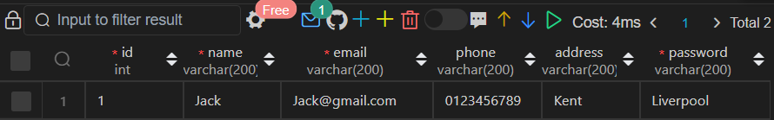

If the user inputs the wrong password, then the following notice will be displayed to the user.

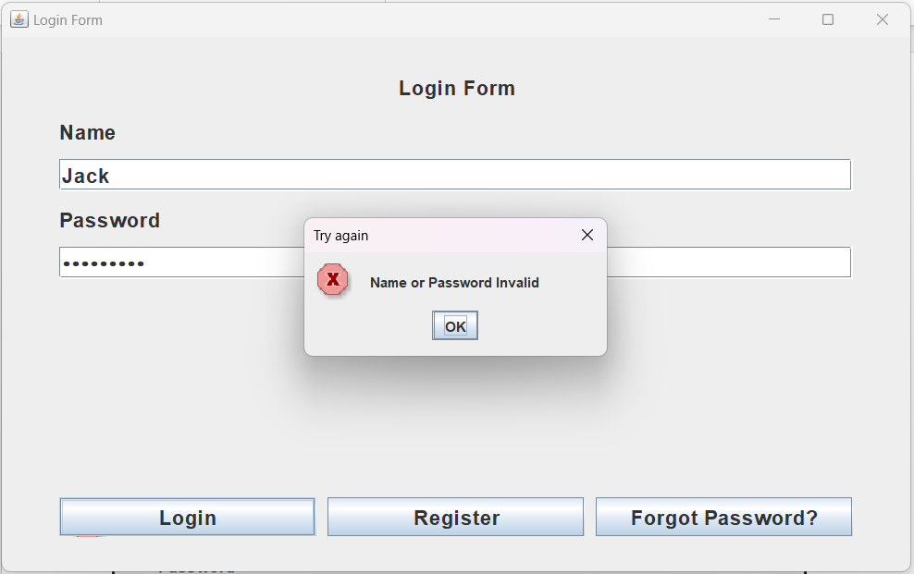

However, if the user does input the correct password, then they are taken to the patient information screen. This screen will be updated /changed towards the end of the project. As this information was use for Testing also, there is an inactivity timer for 2mins then they will be taken back to the login screen

**User registration**

We tested adding a new user to the database and this is the screen that does that.

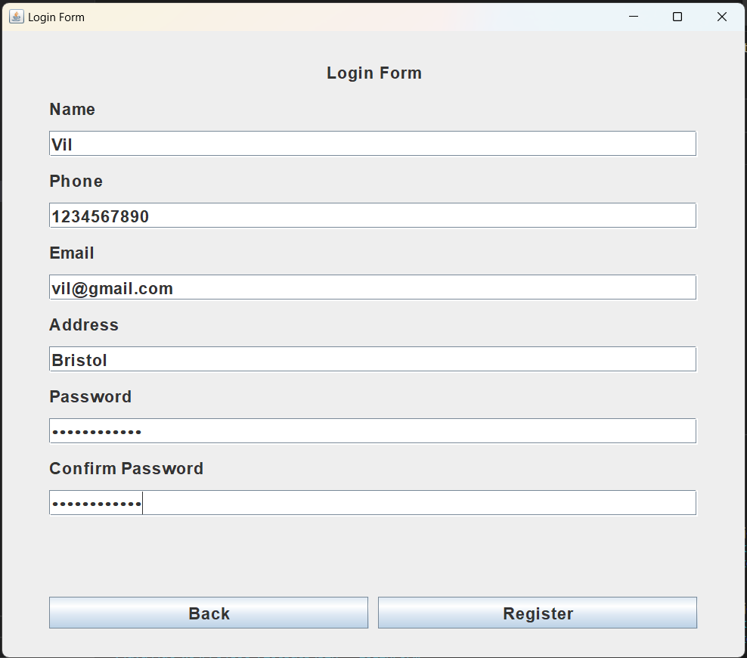

Showing the new user in the database.

